

Course Director: Sean Gray Ref: 1CS-Meet
Date: 07/03/2026

1CSMR & ‘Old’ 2 Med Regt Meet – 3-5 July 26

GENERAL

1. Introduction. Northern Limits Bushcraft and Survival will be hosting the 1 CSMR & ‘Old’ 2 Med Regt Meet at the school located at The Hideaway, Martock, Somerset. It will be a great opportunity for members of both disbanded units to reconnect, reset and reengage friendships and have a break from the world. It is being held on the symbolic dates of the disbandment and formation of 1 CSMR and 2 Med Regt.
- Aim. The Hideaway has a wood block within the grounds that will host the event.

3. Event Outline

a. Intent. The course will run at The Hideaway, Martock, Somerset, TA12 6PQ. What3Words: SCREAMING.MAGPIE.OCCUPIERS on the dates of 3-5 July 2026. You can come and stay for 1 or 2 nights. Bushcraft workshops will be held through the day and social time during the evenings.

b. Timings.

- 1630-1930hrs Fri 3 July 26 – Guest arrival at the Hideaway.

- 2000-2300hrs Fri 3 July 26 – Ice breaker

- Sat 4 July 26 – 0900hrs – 1630hrs – Bushcraft workshop.

- Sat 4 July 26 – 1630hrs – 2300hrs – BBQ and Campfire Dits

- Sun 5 July 26 – 1000hrs – 1200hrs – Bushcraft Finale

- Sun 5 July 26 – 1230hrs – 1430hrs – Wrap up

4. COORDINATING INSTRUCTIONS.

5. Instructor Attendance.

- Sean Gray (Chief Instructor)
- Will McFarland

6. Cost. For the entire event it will cost £15 for the overheads, food for BBQ, fire wood and brew kit. For any addition food or drinks, this will be at your own expense. B.Y.O.B

7. Guest Timings. Key dates and timings are:

- Fri 3 July 26 –
    - Guests arrive at The Hideaway no later than 1930hrs.
    - Receive introduction, safety, and medical brief.
    - Event starts at 1945hrs

- Sun 5 July 26 –
    - Students continue with course
    - Course close down at 1230hrs
8. Med Plan.

- See ANNEX A

9. Kit and Equipment

  - See ANNEX B

10. STUDENTS RETURNS

All students are to return the following Annexes prior to the event starting:

- ANNEX C – Guest details and next of kin form

11. HAIR AND JEWELERY

- All long hair must be tied back into a tail or top knotted as you will be working in close proximity to open flame.

- All jewellery must be removed or taped over.

12. Parking
Once you arrive, you will be met by a member of the Northern Limits staff and walked into to the car park. You will pass the entrance of the school so you can bring your kit into the communal area before parking.

For those that are vehicle camping, you will be guided to ‘The Avenue’ to park and set up.

13. Sleeping Arrangements
You can set up your tarp/hammock up in the wooded area of the school. If you are using a tent, you can set up in the wooded area or in the avenue.

14. Hygiene
Please bring your own hygiene and sanitary products for the duration of the event. We have a composting toilet and handwashing facility on site. We do have a female sanitary box incase needed and disposal bin. There is no shower facility.

15. CONCLUSION

At the end of the event you will have done the following:
-Learnt different fire lighting techniques
-Prepare and cook pigeon
-Find out about edible plants and identifying different trees
-Prepare food and cook it on an open fire
-How to find natural tinders
-Make food out in the field
-Learn different fire lays

All Instructors are DBS checked and are fully insured. We will have a Paramedic on site and all instructors are Emergency Outdoor First Aid trained on site at all times. At no point will any guests be unattended. Your safety is absolutely paramount to us. We want you to achieve maximum success in a safe and relaxed environment.

There will also be times you will be in charge of edged tools. There will be a blade safety lesson at the beginning of the event but a dynamic risk assessment will be made if any of the instructors feel any member of the event is being unsafe. Tool removal will follow and further education will be conducted.

Any questions, queries or quibbles, please call the Chief Instructor at your convenience on 07429999953.

We look forward to seeing you out on the ground!
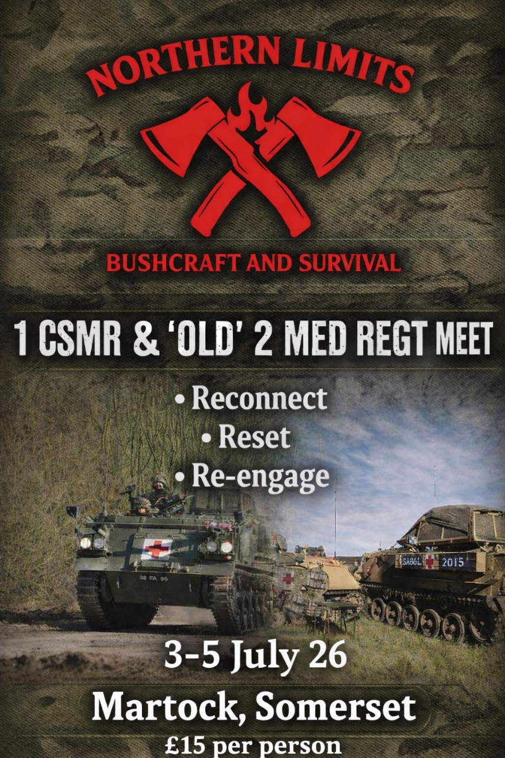


ANNEX A
Med Plan

Course: 1 CSMR & ‘Old’ 2 Med Regt Meet
Course Dates: 3-5 July 2026

In the event of a minor injury, the Chief Instructor (CI) is medically trained and will provide first aid to the individual/s. After treatment is given, further assessment will be made to establish if any further treatment is needed.
If this is the case, an instructor will provide transport for student to the nearest medical facility.

The nearest hospital to The Hideaway is:
Yeovil General Hospital, Higher Kingston, Yeovil, Somerset, BA21 4AT.
Travel Time: 13 Minutes to Northern Limits

If a more serious injury has happened, STOP, STOP, STOP will be called and all instructor and student activity will cease. All tools along with equipment will be made safe and put down by students. Senior Instructor present will command and control and task a triage assessment by medically trained staff. If a serious injury is present, then 999 will be called. An ambulance will be met at a predetermined Emergency Rendezvous Point (ERV) at The Hideaway by a member of staff. This will have been established prior commencing the course.

An instructor or parent/carer will accompany the individual to hospital ensuring student medical forms have been handed to emergency responders. If an individual has become unconscious, Chief Instructor will contact student’s emergency contact to make them aware of the current situation.

Accident form to be filled out by staff and students (when able). Staff will ascertain if any further action needs to be taken to stop it happening again on the End of Course Report.

It is everybody’s responsibility to call STOP, STOP, STOP in the case of an emergency.

A medically trained member of staff will always be on site in close proximity to students. Medical equipment will always be stored within the admin area and is checked daily by a member of staff.
All information on the current location are below.
Accident reporting forms are available in Duty Instructor (DI) folder.

Pos: Chief Instructor Name: Sean Gray Sig: S.Gray Date: 08 Mar 26


ANNEX B

KIT LIST
If you are unable to obtain any of the following, please let us know. We may be able to provide some of the items.
Sleeping System
Please bring your own sleeping bag or wool blanket.
A tarp, tent or hammock, camper van
Roll mat
Pillow
Bivvi Bag

Eating
Plate / Mess Tins
Knife, Fork and Spoon

Drinking
Water bottle (Water Jerry Cans will be provided for fresh water)
Cup (for tea, coffee etc)

Clothing
Warm Clothing
Waterproof Clothing
Appropriate Footwear (Outdoor/Walking shoes or boots)
Spare socks
Spare underwear
Hat/cap
Gloves

Comforts
Camping Stool/Chair
Fabric/Inflatable Pillow
Battery pack (If needed)
Head Torch

Food
You will be required to bring your own food for Friday Evening, Saturday Lunch time and Sunday Morning.
Bring anything else you wish to consume such as snacks, drinks, beers for evening.
Ingredients for making Bannock Bread will be provided.
We will have a cool box and water jerry cans with us.

We will provide food for the BBQ on the Saturday. If you wish to bring any additional food you are more than welcome to bring it to cook on the campfire. Please note any allergies on the student return form.

Medication
If you require medication, please ensure you have enough to last you for the duration.

Carriage
You may wish to bring a backpack, if you do not have one available we are able to transport it by hand as the car park for the wood is 50 metres away from the education area.

Issued Kit (You may bring your own)
Bushcraft Knife Paracord Fire Tinders Food Grill
Folding Saw Tarp/Basha/Poncho Billy Pot Ferro Rod
ANNEX C

Student Details

First Name………………… Last Name………………… Date of Birth…………………

Age……… Email Address…………………………….. Mobile Number…………………

Address………………………………………………………………………………………………………

…………………………………………………………………………………………………………………

Next of Kin/Emergency Contact

First Name………………… Last Name………………… Mobile Number…………………

Relationship…………………

Dietary Needs

………………………………………………………

Health
Do you have any ongoing health conditions that the instructors are to be made aware of that may affect your training? If YES please give a brief description of what limitations you may have. There is always a way around to promote student success.

…………………………………………………………………………

